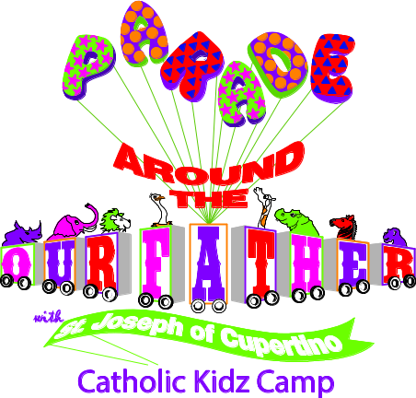
Step Right Up & Join the

POSTAGE



PARENTS!!

IT MAY BE HOT THIS SUMMER,
BUT KIDS WILL BE COOL
IN CATHOLIC KIDZ CAMP!

Dates: June 15-18 Times: 8:30-12:00
Location: St. Mary’s Activity Center
Another NEW and Exciting Catholic Kidz Camp
from Growing with the Saints!

Learn the meaning of the Perfect Prayer on earth
given to us by Jesus,
the Perfect Teacher
Mail this form to:
St. Mary’s Church
317 North Washington Street
Huntingburg, IN 47542
Or Contact:
Name: Rachel Wright
Phone: 812-683-2372
E-mail: rwright@evdio.org

Visit Growing with the Saints at www.growingwiththesaints.com for more Saint Series books for children.
© Growing with the Saints, Inc. - Permission to alter and copy for your program granted.

Child’s Name:
Child’s Name:
Child’s Name:
Parent Name:
Address: Phone:
City: State: Zip:

Prek/K  4-up | Grades  1-2 | Grades  3-4 | Grades  5-6
Can you volunteer to help?
Registration fee per child……. $20
($55 total for three or more children)
I have enclosed a check in the amount of $_______
Please list any allergies here __________________________

